HELP STOP THE CLOAK TIMBER SALE:
Comments Due August 4th

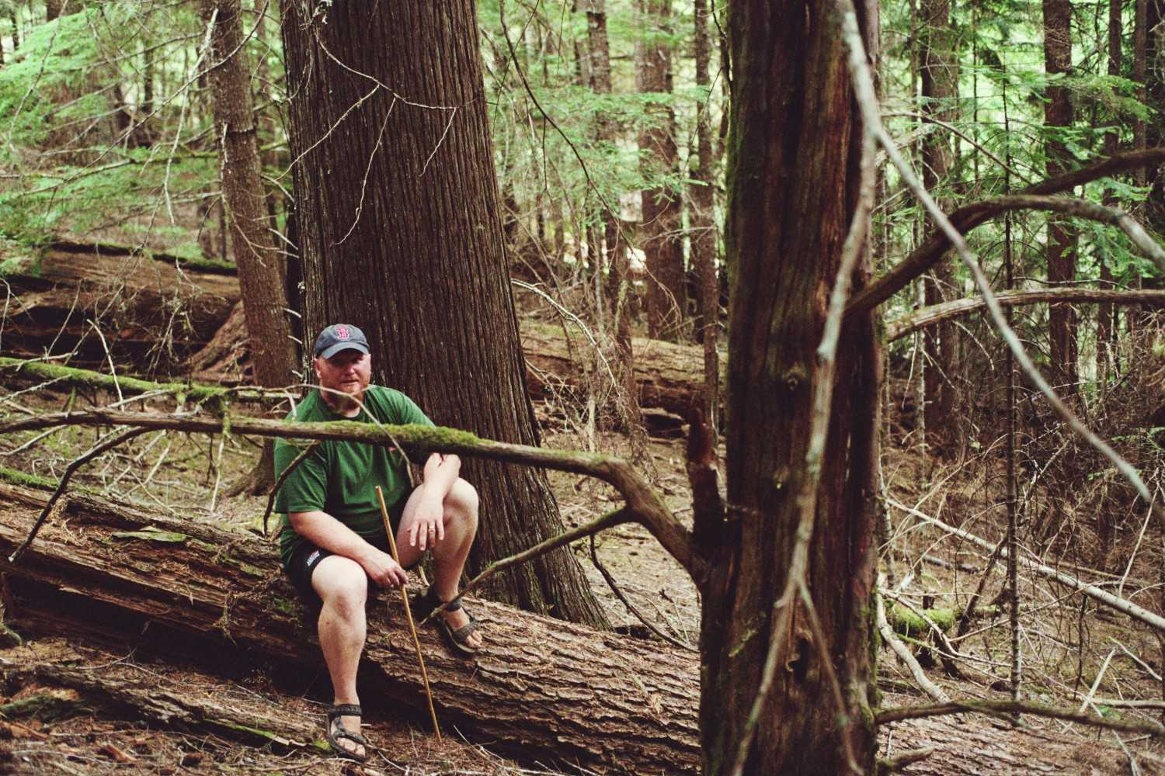
Cloak Unit 466
Send Comments to:
Jim Roden
595 NW Industrial Way
Estacada, OR 97023
comments-pacificnorthwest-mthood-clackamasriver@fs.fed.us

ABOUT THE SALE:
- Will log 1300 acres (over 2 square miles)
- Will log over 200 acres of Riparian Reserve Logging
- Will log within 30-50 feet of streams, road building within 100-150 feet of streams
- Will log over 300 acres of forest with old growth characteristics

MAJOR POINTS:
- No Logging in Native Forests
- No Logging in Riparian Areas (streams, seeps, creeks)
- No Road Building, including Temporary Roads

SAMPLE LETTER:
I am writing to comment on the Preliminary Assessment of the Cloak Thinning Project. I request my comments be included in the public record. I appreciate the distinction made in the planning documents between native forests and commercial plantations as commercial logging is inappropriate for native forests. No more native forest should be converted into plantations or managed as plantations. Please drop all units which log in native forest or riparian (wet) areas. Logging within 30 to 50 feet of streams is unacceptable as is road building within 100 to 150 feet of streams! Please do not build any new roads for this sale, including temporary roads. All units, such as 501, that contain old growth ought to be removed from project plans. Thank you for your consideration of my comments.

Name
Address

