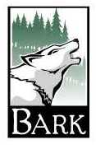 To BMC WEST:
Right now, your store is selling products from companies that are logging on Mt. Hood National Forest and destroying endangered forests around the world. We know there are many sustainably harvested alternatives to selling these products. Companies like Home Deport and distributors such as Golden State Lumber have already stated they will not handle products from endangered forests. We urge you to join them and stop selling products from endangered forests, and from companies that log on public lands, including Mt. Hood National Forest. Until you do so, we will not shop at your store. Additionally, we will specifically request contractors working on any home repairs or remodeling to shop elsewhere.

Name | Address | Phone | Email | I am a Homeowner | I want to volunteer

